# Monthly Attendance Process-Elementary (Detail)

1. Run and Print “Audit Report Listing”

From the Attendance Accounting table, select Print “Attendance Audit Report Listing”

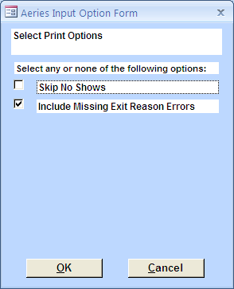

The report will allow you to identify enrollment errors prior to running month-end reports. See “Common Audit Listing Errors” QRS.

# 

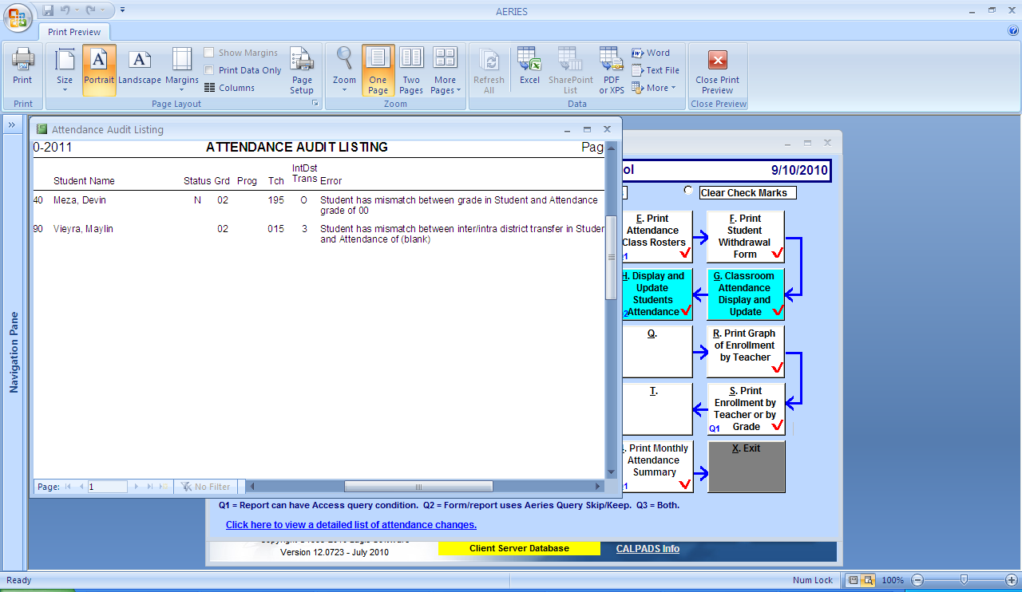

# Run and Print Gains and Losses Report

From the Control Panel, select Attendance Accounting “Print Gains and Losses” (#2). The date will default to the first day of school to the current day. You may adjust dates to the range needed (i.e. 8/23/2010 – 9/17/2010, Mo 1)

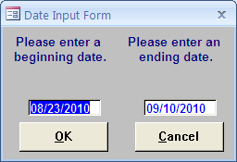

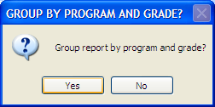 Select “yes”

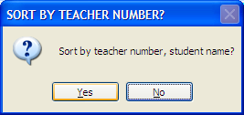Select “yes”

The report produced can be reconciled with the manually-kept “Accessions and Losses Report “ as it lists all transactions in Aeries. Compare the totals for each Instructional Setting to the A & L Report. Research and correct any discrepancies. (See Gains & Losses document).

Note: Reporting Period 1 (8/23/10-9/17/10) lists all entering students as gains. The Carry Forward number for this month only, is zero. When the report is printed for this period, all students will be listed as gains.

# Enter and Reconcile any Saturday School Attendance

Saturday Make-Up attendance should be entered as a part of the weekly duties. After all the attendance for the month has been entered, reconcile for the YTD.

Always keep Saturday School Attendance rosters with the total apportionment absences made up for each week served in a file labeled “Saturday School Rosters”.

Always reconcile for the entire year, not the reporting period, since as a district we permit absences to be made up for three months, the current month and the two prior months. Attempting to reconcile the report by the current reporting period only, will miss any absences that were made up by serving Saturday School Make-up in the two prior months.

From the Control Table, select “Attendance Accounting”, then “Print Students with n or more absences” (W).

A box, subInputCodes/special will appear

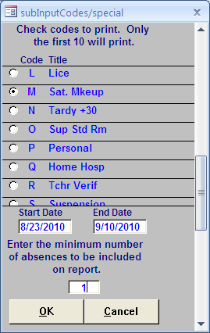

Check only box “M” Sat. Makeup. The date parameter should be from the first day of school to the last day of the reporting period or the current date. Minimum number of days should be “1”.

 Select “yes”

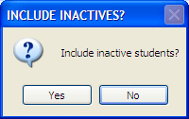 Select “yes” (Very Important)

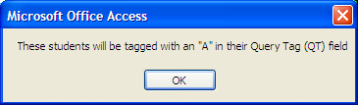 “ok”

This just identifies students as part of a query.

The report will list all students who have made up an absence with a Saturday attendance. You must count by hand the number of Saturday School days, also total the number of students (students who have served more than one day are counted as one)

As you total the number of apportionment absences from all the rosters back to the beginning of the year to date, the totals should reconcile.

# Run and Print Monthly Attendance Report

After you have cleared any errors from the Audit Listing, reconciled “Gains and Losses” report with the A&L report and reconciled Saturday School input and attendance, you are ready to run the “Monthly Attendance Report” (detail).

From the Attendance Accounting table, select “Print Monthly Attendance Report” (#3)

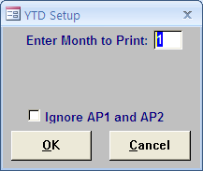 Select month to print and “OK”

You will get a notice that you have XX of unverified Absences

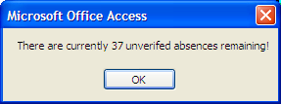 Select “OK”

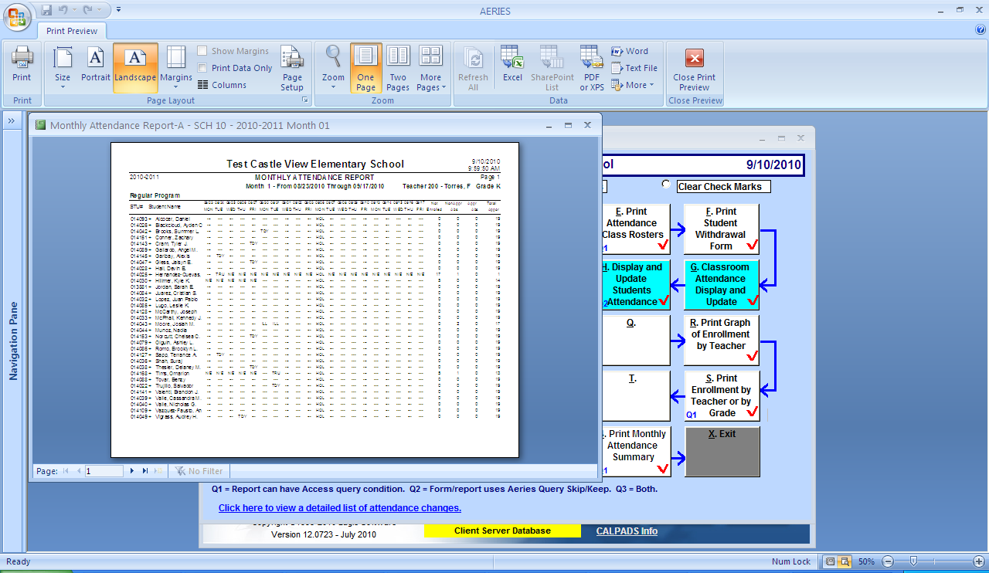

This is a detail report listing all classes and attendance in a detailed format by Instructional Setting.

You will utilize the totals pages for each Instructional Setting to reconcile with the “Monthly Attendance Summary”

To run the Summary report, select #4, Monthly Summary Report. The following message will appear,

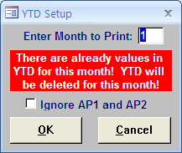

This box warns you that the YTD totals will be updated with this more current information, click “OK”

The following box appears warning you that if there is data in subsequent months, you must “run” any subsequent months.

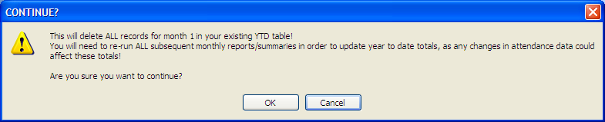

**IMPORTANT! You must run any subsequent months if there have been any changes due to revisions. Revisions affecting apportionment or enrollment will change the YTD totals. The process of “updating” re-opening and re-running the subsequent months assures that all YTD totals are updated with the changes.**

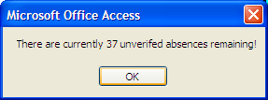

Another warning about unverified absences, click “OK”

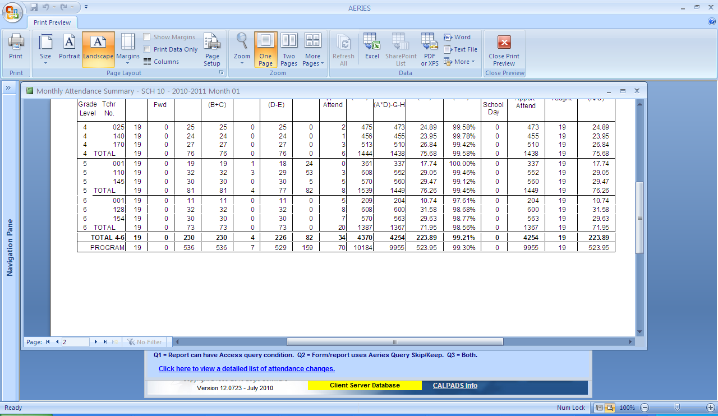

The totals page should reconcile with the detail report, “Monthly Attendance Report”. It should also agree with the A & L report.

**Run both reports, Monthly Attendance and Monthly Summary Reports one after another to assure accuracy.**

# Submission of Monthly Reports to Attendance Accounting

Prepare a folder at your site, clearly labeled with the Reporting Month, to keep all information for the month in a well-organized manner. ***Original Reports will be kept on site, including any revisions, filed with the most current report in front. See below for Revision process.***

On the Attendance Calendar, identify Report Due dates by “#”. Reports must be submitted so that they are received in Attendance Accounting by the specified due date.

Attendance Accounting Must Receive:

1. Copies of totals pages for all Programs of the “Monthly Attendance Report”
2. Copy of the entire “Monthly Summary Report”
3. Copy of all pages of A & L
4. Copy of “Gains and Losses” report
5. Copy of Blank “Audit Listing” (all errors corrected)
6. Independent Study Roster
7. Copies of any Saturday School Rosters with Report from Aeries.

**REVISIONS- Do NOT send in revisions with your monthly reports. Sites will be notified by E-Mail when they are to turn in revisions. It will be in the few weeks prior to the major reporting periods, P-1, P-2 and Annual. You will be given explicit instructions at that time. Continue to maintain your files as they need to be up-to-date.**